



***Liaoning Normal University***

**基于Javaweb考试功能**

**设计与实现实验报告**

**课程名称：Javaweb编程基础**

**专业：计算机科学与技术（师范）**

**班级： （1） 班**

**学号：201621012299**

**姓名：周惠馨**

**指导教师：金百东**

**2018年12月16日**

目录

**一、 实验目的** **3**

**二、 实验设备及系统环境** **3**

**三、 实验要求** **3**

1、 注册功能 3

2、 登录功能 3

3、 主界面 3

4、 成绩查询功能 3

**四、 实验代码** **4**

1、数据库代码： 4

2、main.jsp 4

3、menu.jsp 5

4、welcome.jsp 6

5、top.jsp 6

6、spbar.jsp 7

7、login.jsp 8

8、regist.jsp 9

9、single.jsp 9

10、double.jsp 10

11、query.jsp 11

12、grade1.jsp 11

13、grade2.jsp 13

14、User.java 14

15、Grade.java 15

16、DBUtil.java 16

17、Login.java 17

18、Regist.java 19

19、Answer.java 20

20、Answer2.java 22

21、Query.java 24

**五、 实验结果** **26**

**六、 实现结果分析** **31**

1. 实验目的

掌握JavaBean、Servlet、数据库等知识的综合应用。

1. 实验设备及系统环境

Eclipse、Access、Tomcat、sql

1. 实验要求
2. 注册功能
3. 登录功能
4. 主界面

准考证号：111111 姓名：aaa 学院：计信学院

单选

多选

填空

均是客观题。当选择“单选”，在答题区出现“单选”的所有试题，并有“保存”按钮。

以此类推实现“多选”等其它功能。

1. 成绩查询功能
2. 个人查询：

输入准考证号，可查询相应学生成绩信息，包括如下信息：

准考证号：111111 姓名：张

|  |  |  |
| --- | --- | --- |
| **单选** | **多选** | **总分** |
| 40 | 45 | 85 |

2）模糊查询：

按准考证进行模糊查询。显示格式如下。

|  |  |  |  |
| --- | --- | --- | --- |
| **序号** | **准考证号** | **姓名** | **总成绩** |
|  |  |  |  |
|  |  |  |  |
|  |  |  |  |
|  |  |  |  |
|  |  |  |  |

3）上述是实现的基本功能，同学们可进一步丰富。

自行设计所需要的各种数据库表。

1. 实验代码

1、数据库代码：

CREATE DATABASE IF NOT EXISTS `user` CHARACTER SET utf8 COLLATE utf8_general_ci;

USE `user`;

DROP TABLE IF EXISTS `user`.`grade`;

CREATE TABLE `user`.`grade` (

`user` varchar(30),

`studno` varchar(16),

`realName` varchar(100),

`single_answer` varchar(20),

`double_answer` varchar(50),

`single_grade` varchar(20),

`double_grade` varchar(20),

primary key(`user`,`studno`)

)ENGINE=InnoDB DEFAULT CHARSET=utf8;

DROP TABLE IF EXISTS `user`.`user`;

CREATE TABLE `user`.`user` (

`user` varchar(30),

`pwd` varchar(30),

`realName` varchar(100),

`age` varchar(4),

`studno` varchar(16),

primary key(`user`)

) ENGINE=InnoDB DEFAULT CHARSET=utf8;

2、main.jsp

<%@ page language=*"java"* contentType=*"text/html; charset=UTF-8"*

pageEncoding=*"UTF-8"*%>

<!DOCTYPE html PUBLIC "-//W3C//DTD HTML 4.01 Transitional//EN" "http://www.w3.org/TR/html4/loose.dtd">

<html>

<head>

<meta http-equiv=*"Content-Type"* content=*"text/html; charset=UTF-8"*>

<title></title>

</head>

<frameset id=*"fbody"* rows=*"50,*"* frameborder=*"no"* border=*"0"* framespacing=*"0"*>

<frame id=*"top"* name=*"top"* src=*"top.jsp"* scrolling=*"no"* noresize frameborder=*"0"* marginheight=*"0"* marginwidth=*"0"*>

<frameset id=*"forum"* cols=*"200,*"* framespacing=*"0"* frameborder=*"no"* border=*"0"* rows=*"*"*>

<frame id=*"menu"* name=*"menu"* src=*"spbar.jsp"* scrolling=*"no"* frameborder=*"0"* marginheight=*"0"* marginwidth=*"0"*>

<frameset id=*"content"* rows=*"*,40"* framespacing=*"0"* frameborder=*"no"* border=*"0"* cols=*"*"*>

<frame id=*"main"* name=*"main"* src=*"welcome.jsp"*>

</frameset>

</frameset>

</frameset>

<noframes>

<body>

</body>

</noframes>

</html>

3、menu.jsp

<%@ page language=*"java"* contentType=*"text/html; charset=UTF-8"*

pageEncoding=*"UTF-8"*%>

<!DOCTYPE html PUBLIC "-//W3C//DTD HTML 4.01 Transitional//EN" "http://www.w3.org/TR/html4/loose.dtd">

<html>

<head>

<meta http-equiv=*"Content-Type"* content=*"text/html; charset=UTF-8"*>

<title></title>

</head>

<body>

<table border=*"1"* bgcolor=*"#f0f0f0"* width=*"100%"*>

<tr><td align=*"center"*><a align=*"center"* href=*"single.jsp"* target=*"main"* title=*"单选"*>单选</a></td></tr>

</table>

<table border=*"1"* bgcolor=*"#f0f0f0"* width=*"100%"*>

<tr><td align=*"center"*><a align=*"center"* href=*"double.jsp"* target=*"main"* title=*"多选"*>多选</a></td></tr>

</table>

<table border=*"1"* bgcolor=*"#f0f0f0"* width=*"100%"*>

<tr><td align=*"center"*><a href=*"query.jsp"* target=*"main"* title=*"成绩查询"*>成绩查询</a></td></tr>

</table>

</body>

</html>

4、welcome.jsp

<%@ page language=*"java"* contentType=*"text/html; charset=UTF-8"*

pageEncoding=*"UTF-8"*%>

<!DOCTYPE html PUBLIC "-//W3C//DTD HTML 4.01 Transitional//EN" "http://www.w3.org/TR/html4/loose.dtd">

<html>

<head>

<meta http-equiv=*"Content-Type"* content=*"text/html; charset=UTF-8"*>

<title>欢迎</title>

</head>

<body background=*"photo/3.jpg"*>

<table width=*"100%"* height=*"100%"*>

<tr><td width=*"100%"* height=*"300"* align=*"center"* valign=*"middle"*>

<font style=font-size:*30px*; font-weight:bold>开始考试</font>

</td></tr>

</table>

</body>

</html>

</body>

</html>

5、top.jsp

<%@ page language=*"java"* contentType=*"text/html; charset=UTF-8"*

pageEncoding=*"UTF-8"*%>

<!DOCTYPE html PUBLIC "-//W3C//DTD HTML 4.01 Transitional//EN" "http://www.w3.org/TR/html4/loose.dtd">

<html>

<head>

<meta http-equiv=*"Content-Type"* content=*"text/html; charset=UTF-8"*>

<title>标题页</title>

</head>

<body bgcolor=*"#eeeeee"*>

<p class=*"title"* align=*"center"*><font style=font-size:*30px*; font-weight:bold>考试系统</font></p>

</body>

</html>

6、spbar.jsp

<%@ page language=*"java"* contentType=*"text/html; charset=UTF-8"*

pageEncoding=*"UTF-8"*%>

<!DOCTYPE html PUBLIC "-//W3C//DTD HTML 4.01 Transitional//EN" "http://www.w3.org/TR/html4/loose.dtd">

<html>

<head>

<meta http-equiv=*"Content-Type"* content=*"text/html; charset=UTF-8"*>

<title></title>

<style type=*"text/css"*>

*.point* {

font-size: *10px*;

cursor: *pointer*;

color: *#000000*;

font-family: *"宋体"*;

position: *absolute*;

background-color: *#7B8D91*;}

*.spline1*{

background-color: *#7B8D91*;}

*.spBgColor*{

cursor: *pointer*;

background-color: *#7B8D91*;}

</style>

<script language=*"javascript"*>

**function** changeWin(evt){

evt = evt ? evt:(window.event?window.event:**null**);

**if**(window.top.document.getElementById("forum").cols != "8,*"){

window.top.document.getElementById("forum").cols = "8,*";

document.getElementById("menuSwitch").innerHTML = "<font class=point>&gt;&gt;</font>";

}**else**{

window.top.document.getElementById("forum").cols = "200,*";

document.getElementById("menuSwitch").innerHTML = "<font class=point>&lt;&lt;</font>";

}

}

</script>

</head>

<body>

<table height=*"100%"* cellSpacing=*"0"* cellPadding=*"0"* width=*"100%"* border=*"0"*>

<tbody><tr>

<td width=*"100%"*>

<iframe id=*"trview"* name=*"trview"* style="visibility:*inherit*; width:*100%*; height:*100%*" src=*"menu.jsp"* frameborder=*"0"* marginwidth=*"0"*></iframe>

</td><td class=*"spline1"*><img height=*"1"* width=*"1"*></td>

<td class=*"spBgColor"*>

<table height=*"100%"* cellSpacing=*"0"* cellPadding=*"0"* width=*"100%"* border=*"0"*>

<tbody><tr><td onclick="changeWin(event);" height=*"1"*>

<img height=*"1"* width=*"8"*></td></tr><tr>

<td id=*"menuSwitch"* onclick="changeWin(event);" height=*"100%"*>

<font class=*"point"*>&lt;&lt;</font></td></tr>

</tbody></table>

</td></tr>

</tbody>

</table>

</body>

</html>

7、login.jsp

<%@ page language=*"java"* contentType=*"text/html; charset=UTF-8"*

pageEncoding=*"UTF-8"*%>

<!DOCTYPE html PUBLIC "-//W3C//DTD HTML 4.01 Transitional//EN" "http://www.w3.org/TR/html4/loose.dtd">

<html>

<head>

<meta http-equiv=*"Content-Type"* content=*"text/html; charset=UTF-8"*>

<title>考试系统登录页面</title>

<meta http-equiv=*"pragma"* content=*"no-cache"*>

<meta http-equiv=*"cache-control"* content=*"no-cache"*>

<meta http-equiv=*"expires"* content=*"0"*>

<meta http-equiv=*"keywords"* content=*"k；eyword1,keyword2,keyword3"*>

<meta http-equiv=*"description"* content=*"This is my page"*>

</head>

<body background=*"photo/3.jpg"*>

<form method=*"post"* action=*"Login"* name=*"frm"*>

<h1 align=*"center"*>

<font>欢迎登录考试系统<br/><br/></h1>

<p align=*"center"*>

用户账户： <input type=*"text"* style="width:*200px*;" name=*"user"* value=*""*><br/>

登录密码： <input type=*"password"* style="width:*200px*;" name=*"pwd"* value=*""*><br/><br/>

<input type=*"submit"* size=*"30"* value=*"登录账号"* name=*"login"*>

<input type=*"submit"* size=*"30"* value=*"注册账号"* name=*"login"*><br/><br/></p>

<p align=*"center"*>Copyright@ 2009-2018 版权所有 辽宁师范大学</p></font>

</form>

</body>

</html>

8、regist.jsp

<%@ page language=*"java"* contentType=*"text/html; charset=UTF-8"*

pageEncoding=*"UTF-8"*%>

<!DOCTYPE html PUBLIC "-//W3C//DTD HTML 4.01 Transitional//EN" "http://www.w3.org/TR/html4/loose.dtd">

<html>

<head>

<meta http-equiv=*"Content-Type"* content=*"text/html; charset=UTF-8"*>

<title>注册账户</title>

<style>

*.a*{width: *200px*;}

*#b*{

width: *500px*;

text-align: *right*; /*右对齐*/·

}

</style>

</head>

<body background=*"photo/3.jpg"*>

<div id=*"b"*>

<form action=*"Regist"* method=*"post"*>

用户名:<input type=*"text"* class=*"a"* name=*"user"*><br>

密码:<input type=*"text"* class=*"a"* name=*"pwd"*><br>

真实姓名:<input type=*"text"* class=*"a"* name=*"realname"*><br>

年龄:<input type=*"text"* class=*"a"* name=*"age"*><br>

学号:<input type=*"text"* class=*"a"* name=*"studno"*><br>

<input type=*"submit"* class=*"a"* value=*"注册账号"*>

</form>

</div>

</body>

</html>

9、single.jsp

<%@ page language=*"java"* contentType=*"text/html; charset=UTF-8"*

pageEncoding=*"UTF-8"*%>

<!DOCTYPE html PUBLIC "-//W3C//DTD HTML 4.01 Transitional//EN" "http://www.w3.org/TR/html4/loose.dtd">

<html>

<head>

<meta http-equiv=*"Content-Type"* content=*"text/html; charset=UTF-8"*>

<title>单选</title>

</head>

<body background=*"photo/3.jpg"*>

<FONT size=*4*>

<FORM action=*"Answer"*method=*post* name=*form*>

<P>中国的首都是: <BR>

<INPUT type=*"radio"* name=*"r0"* value=*"a"*>北京

<INPUT type=*"radio"* name=*"r0"* value=*"b"*>大连

<INPUT type=*"radio"* name=*"r0"* value=*"c"*>上海

<INPUT type=*"radio"* name=*"r0"* value=*"d"*>天津

<P>美国的首都是: <BR>

<INPUT type=*"radio"* name=*"r1"* value=*"a"*>罗马

<INPUT type=*"radio"* name=*"r1"* value=*"b"*>华盛顿

<INPUT type=*"radio"* name=*"r1"* value=*"c"*>希腊

<INPUT type=*"radio"* name=*"r1"* value=*"d"*>纽约

<BR>

<br>

<INPUT TYPE=*"submit"* value=*"提交答案"* name=*"submit"*>

</FORM>

</FONT>

</body>

</html>

10、double.jsp

<%@ page language=*"java"* contentType=*"text/html; charset=UTF-8"*

pageEncoding=*"UTF-8"*%>

<!DOCTYPE html PUBLIC "-//W3C//DTD HTML 4.01 Transitional//EN" "http://www.w3.org/TR/html4/loose.dtd">

<html>

<head>

<meta http-equiv=*"Content-Type"* content=*"text/html; charset=UTF-8"*>

<title>多选</title>

</head>

<body background=*"photo/3.jpg"*>

<FONT size=*4*>

<FORM action=*"Answer2"*method=*post* name=*form*>

<P>我国四大古典小说: <BR>

<INPUT type=*"checkbox"* name=*"r0"* value=*"a"*>《水浒传》

<INPUT type=*"checkbox"* name=*"r0"* value=*"b"*>《三国演义》

<INPUT type=*"checkbox"* name=*"r0"* value=*"c"*>《红楼梦》

<INPUT type=*"checkbox"* name=*"r0"* value=*"d"*>《西游记》

<P>四大名绣: <BR>

<INPUT type=*"checkbox"* name=*"r1"* value=*"a"*>苏绣

<INPUT type=*"checkbox"* name=*"r1"* value=*"b"*>湘绣

<INPUT type=*"checkbox"* name=*"r1"* value=*"c"*>粤绣

<INPUT type=*"checkbox"* name=*"r1"* value=*"d"*>蜀绣<!-- checked="ok" -->

<BR>

<br>

<INPUT TYPE=*"submit"* value=*"提交答案"* name=*"submit"*>

</FORM>

</FONT>

</body>

</html>

11、query.jsp

<%@ page language=*"java"* contentType=*"text/html; charset=UTF-8"*

import =*"javaweb.*"*

pageEncoding=*"UTF-8"*%>

<!DOCTYPE html PUBLIC "-//W3C//DTD HTML 4.01 Transitional//EN" "http://www.w3.org/TR/html4/loose.dtd">

<html>

<head>

<meta http-equiv=*"Content-Type"* content=*"text/html; charset=UTF-8"*>

<title>成绩查询页面</title>

<style>

*.a*{width: *200px*;}

*#b*{

width: *300px*;

text-align: *right*; /*右对齐*/·

}

</style>

</head>

<body background=*"photo/3.jpg"*>

<div id=*"b"*>

<form action=*"Query"*>

学生证号:<input type=*"text"* class=*"a"* name=*"studno"*><br>

<input type=*"submit"* style="width:*100px*" name=*"query"* value=*"个人查询"*>

<input type=*"submit"* style="width:*100px*" name=*"query"* value=*"模糊查询"*><br>

<input type=*"submit"* style="width:*200px*" name=*"query"* value=*"结束考试"*><br>

</form>

</div>

</body>

</html>

12、grade1.jsp

<%@ page language=*"java"* contentType=*"text/html; charset=UTF-8"*

pageEncoding=*"UTF-8"*%>

<!DOCTYPE html PUBLIC "-//W3C//DTD HTML 4.01 Transitional//EN" "http://www.w3.org/TR/html4/loose.dtd">

<html>

<head>

<meta http-equiv=*"Content-Type"* content=*"text/html; charset=UTF-8"*>

<title>个人成绩页面</title>

</head>

<body background=*"photo/3.jpg"*>

<%

**int** single_grade=(Integer)session.getAttribute("single_grade");

**int** double_grade=(Integer)session.getAttribute("double_grade");

**int** sum=single_grade+double_grade;

%>

<table width=*"100%"* border=*"0"* cellspacing=*"1"* cellpadding=*"0"* class=*""*>

<tr bgcolor=*"#fba661"* height=*"25"*>

<td width=*"15%"* bgcolor= *"#a0a0a0"*>

<div align=*"center"*>

单选成绩

</div>

</td>

<td width=*"15%"* bgcolor= *"#a0a0a0"*>

<div align=*"center"*>

多选成绩

</div>

</td>

<td width=*"18%"* bgcolor=*"#a0a0a0"*>

<div align=*"center"*>

总成绩

</div>

</td>

</tr>

<tr bgcolor=*"#f3f3f3"* height=*"25"*>

<td width=*"15%"* >

<div align=*"center"*>

<%=single_grade%>

</div>

</td>

<td width=*"15%"* >

<div align=*"center"*>

<%=double_grade%>

</div>

</td>

<td width=*"18%"*>

<div align=*"center"*>

<%=sum%>

</div>

</td>

</tr>

</table>

</body>

</html>

13、grade2.jsp

<%@ page language=*"java"* contentType=*"text/html; charset=UTF-8"*

import=*"javaweb.*"*

import=*"java.util.*"*

pageEncoding=*"UTF-8"*%>

<!DOCTYPE html PUBLIC "-//W3C//DTD HTML 4.01 Transitional//EN" "http://www.w3.org/TR/html4/loose.dtd">

<html>

<head>

<meta http-equiv=*"Content-Type"* content=*"text/html; charset=UTF-8"*>

<title>模糊成绩页面</title>

</head>

<body background=*"photo/3.jpg"*>

<table width=*"100%"* border=*"0"* cellspacing=*"1"* cellpadding=*"0"* class=*""*>

<tr bgcolor=*"#fba661"* height=*"25"*>

<td width=*"12%"* bgcolor= *"#a0a0a0"*>

<div align=*"center"*>

用户名

</div>

</td>

<td width=*"12%"* bgcolor= *"#a0a0a0"*>

<div align=*"center"*>

学号

</div>

</td>

<td width=*"12%"* bgcolor=*"#a0a0a0"*>

<div align=*"center"*>

姓名

</div>

</td>

<td width=*"12%"* bgcolor=*"#a0a0a0"*>

<div align=*"center"*>

总成绩

</div>

</td>

</tr>

<%

List list=(List)session.getAttribute("gradelist");

Iterator its=list.iterator();//迭代器，提供一种方法访问一个容器对象中各个元素，而又不需暴露该对象的内部细节。

**while**(its.hasNext()){

Grade g=**new** Grade();

g=(Grade)its.next();

**int** sum=g.getSingle_grade()+g.getDouble_grade();

%>

<tr bgcolor=*"#f3f3f3"* height=*"25"*>

<td width=*"12%"* >

<div align=*"center"*>

<%=g.getUser()%>

</div>

</td>

<td width=*"12%"* >

<div align=*"center"*>

<%=g.getStudno()%>

</div>

</td>

<td width=*"12%"*>

<div align=*"center"*>

<%=g.getRealName()%>

</div>

</td>

<td width=*"12%"*>

<div align=*"center"*>

<%=sum%>

</div>

</td>

</tr>

<%

}

%>

</table>

</body>

</html>

14、User.java

**package** javaweb;

**public** **class** User {

**private** String user;

**private** String pwd;

**private** String realName;

**private** String age;

**private** String studno;

**public** String getUser() {

**return** user;

}

**public** **void** setUser(String user) {

**this**.user = user;

}

**public** String getPwd() {

**return** pwd;

}

**public** **void** setPwd(String pwd) {

**this**.pwd = pwd;

}

**public** String getRealName() {

**return** realName;

}

**public** **void** setRealName(String realName) {

**this**.realName = realName;

}

**public** String getAge() {

**return** age;

}

**public** **void** setAge(String age) {

**this**.age = age;

}

**public** String getStudno() {

**return** studno;

}

**public** **void** setStudno(String studno) {

**this**.studno = studno;

}

}

15、Grade.java

**package** javaweb;

**public** **class** Grade {

**private** String user;

**private** String studno;

**private** String realName;

**private** String single_answer;

**private** String double_answer;

**private** **int** single_grade;

**private** **int** double_grade;

**public** String getUser() {

**return** user;

}

**public** **void** setUser(String user) {

**this**.user = user;

}

**public** String getStudno() {

**return** studno;

}

**public** **void** setStudno(String studno) {

**this**.studno = studno;

}

**public** String getRealName() {

**return** realName;

}

**public** **void** setRealName(String realName) {

**this**.realName = realName;

}

**public** String getSingle_answer() {

**return** single_answer;

}

**public** **void** setSingle_answer(String single_answer) {

**this**.single_answer = single_answer;

}

**public** String getDouble_answer() {

**return** double_answer;

}

**public** **void** setDouble_answer(String double_answer) {

**this**.double_answer = double_answer;

}

**public** **int** getSingle_grade() {

**return** single_grade;

}

**public** **void** setSingle_grade(**int** single_grade) {

**this**.single_grade = single_grade;

}

**public** **int** getDouble_grade() {

**return** double_grade;

}

**public** **void** setDouble_grade(**int** double_grade) {

**this**.double_grade = double_grade;

}

}

16、DBUtil.java

**package** javaweb;

**import** java.sql.*;

**public** **class** DBUtil {

//数据库的用户信息

**private** **static** String *rootname*="root";

**private** **static** String *rootpass*="root";

//MySOL的驱动程序

**private** **static** String *driver*="com.mysql.jdbc.Driver";

//数据库的位置

**private** **static** String *url*="jdbc:mysql://localhost:3306/user";

//创建与数据库连接

**public** **static** Connection getConnection()**throws** InstantiationException,IllegalAccessException,ClassNotFoundException,SQLException{

Class.*forName*(*driver*).newInstance();

**return** DriverManager.*getConnection*(*url*,*rootname*,*rootpass*);

}

}

17、Login.java

**package** javaweb;

**import** java.io.IOException;

**import** java.io.PrintWriter;

**import** java.sql.Connection;

**import** java.sql.PreparedStatement;

**import** java.sql.ResultSet;

**import** javaweb.DBUtil;

**import** javaweb.User;

**import** javax.servlet.ServletException;

**import** javax.servlet.annotation.WebServlet;

**import** javax.servlet.http.HttpServlet;

**import** javax.servlet.http.HttpServletRequest;

**import** javax.servlet.http.HttpServletResponse;

**import** javax.servlet.http.HttpSession;

/**

* Servlet implementation class Login

*/

@WebServlet("/Login")

**public** **class** Login **extends** HttpServlet {

**private** **static** **final** **long** *serialVersionUID* = 1L;

/**

* **@see** HttpServlet#HttpServlet()

*/

**public** Login() {

**super**();

// **TODO** Auto-generated constructor stub

}

/**

* **@see** HttpServlet#service(HttpServletRequest request, HttpServletResponse response)

*/

**protected** **void** service(HttpServletRequest request, HttpServletResponse response) **throws** ServletException, IOException {

// **TODO** Auto-generated method stub

response.setContentType("text/html");

response.setCharacterEncoding("UTF-8");

String login=request.getParameter("login");

String login1=**new** String(login.getBytes("ISO-8859-1"),"UTF-8");

PrintWriter out=response.getWriter();//输出页面

**if**(login1.equals("登录账号")){

String user=request.getParameter("user");

String pwd=request.getParameter("pwd");

**boolean** mark = **true**;

**try**{

Connection con=DBUtil.*getConnection*();

**if**(con==**null**)

System.*out*.println("数据库未连接");

String strSQL = "select * from user where user=? and pwd=?";

PreparedStatement pstm = con.prepareStatement(strSQL);

System.*out*.println("strSQL="+strSQL);

pstm.setString(1, user);

pstm.setString(2, pwd);

ResultSet rst = pstm.executeQuery();//跟数据库某一张具体的表产生交互，并获得其中的数据，获得该数据的结果集

**if**(rst.next()){

String name = rst.getString("realname");

String age = rst.getString("age");

String studno = rst.getString("studno");

User u = **new** User();

u.setUser(user);

u.setPwd(pwd);

u.setAge(age);

u.setRealName(name);

u.setStudno(studno);

HttpSession session = request.getSession();

session.setAttribute("user",u);

}

**else**{

mark=**false**;

}

pstm.close();

con.close();

**if**(mark==**true**)

response.sendRedirect("main.jsp");

**else**

{

out.print("没有注册账号！"+"<br>");

out.print("<a href='login.jsp'>注册账号</a>");

}

}**catch**(Exception e){

e.printStackTrace();

}

}

**else**{

response.sendRedirect("regist.jsp");//地址栏会改变，request作用域丢失

}

}

}

18、Regist.java

**package** javaweb;

**import** java.io.IOException;

**import** java.io.PrintWriter;

**import** java.sql.*;

**import** javax.servlet.ServletException;

**import** javax.servlet.annotation.WebServlet;

**import** javax.servlet.http.HttpServlet;

**import** javax.servlet.http.HttpServletRequest;

**import** javax.servlet.http.HttpServletResponse;

/**

* Servlet implementation class Regist

*/

@WebServlet("/Regist")

**public** **class** Regist **extends** HttpServlet {

**private** **static** **final** **long** *serialVersionUID* = 1L;

/**

* **@see** HttpServlet#HttpServlet()

*/

**public** Regist() {

**super**();

// **TODO** Auto-generated constructor stub

}

/**

* **@see** HttpServlet#service(HttpServletRequest request, HttpServletResponse response)

*/

**protected** **void** service(HttpServletRequest request, HttpServletResponse response) **throws** ServletException, IOException {

// **TODO** Auto-generated method stub

response.setContentType("text/html");

response.setCharacterEncoding("UTF-8");

request.setCharacterEncoding("UTF-8");

String user=request.getParameter("user");

String pwd=request.getParameter("pwd");

String realname=request.getParameter("realname");

String age=request.getParameter("age");

String studno=request.getParameter("studno");

PrintWriter out=response.getWriter();

**try**{

Connection con=DBUtil.*getConnection*();

**if**(con==**null**)

System.*out*.println("数据库未连接");

String strSQL="insert into user values("+"'"+user+"',"+"'"+pwd+"'," +"'"+realname+"',"+"'"+age+"',"+"'"+studno+"')" ;

Statement stm=con.createStatement();

stm.executeUpdate(strSQL);

System.*out*.print("strSQL="+strSQL);

stm.close();

con.close();

out.print("注册账号成功!"+"<br>");

out.print("<a href='login.jsp'>登录账号</a>");

}**catch**(Exception e){

e.printStackTrace();

}

}

}

19、Answer.java

**package** javaweb;

**import** java.io.IOException;

**import** java.io.PrintWriter;

**import** java.sql.Connection;

**import** java.sql.PreparedStatement;

**import** javax.servlet.ServletException;

**import** javax.servlet.annotation.WebServlet;

**import** javax.servlet.http.HttpServlet;

**import** javax.servlet.http.HttpServletRequest;

**import** javax.servlet.http.HttpServletResponse;

**import** javax.servlet.http.HttpSession;

**import** javaweb.DBUtil;

**import** javaweb.User;

/**

* Servlet implementation class Answer

*/

@WebServlet("/Answer")

**public** **class** Answer **extends** HttpServlet {

**private** **static** **final** **long** *serialVersionUID* = 1L;

/**

* **@see** HttpServlet#HttpServlet()

*/

**public** Answer() {

**super**();

// **TODO** Auto-generated constructor stub

}

/**

* **@see** HttpServlet#service(HttpServletRequest request, HttpServletResponse response)

*/

**protected** **void** service(HttpServletRequest request, HttpServletResponse response) **throws** ServletException, IOException {

// **TODO** Auto-generated method stub

response.setContentType("text/html");

response.setCharacterEncoding("UTF-8");

PrintWriter out=response.getWriter();

String s[]={"a","b"};

String result="";

**int** n=0;

**for**(**int** i=0;i<s.length;i++){

String answer=request.getParameter("r"+i);

result+=answer;

**if**(answer.equals(s[i])){

n++;

}

}

System.*out*.println("answer==="+result);

String strSQL="insert into grade values(?,?,?,?,?,?,?)";

HttpSession session=request.getSession();

User u=(User)session.getAttribute("user");

**try**{

Connection con=DBUtil.*getConnection*();

**if**(con==**null**)

System.*out*.println("数据库未连接");

PreparedStatement pstm = con.prepareStatement(strSQL);

System.*out*.println("strSQL="+strSQL);

pstm.setString(1, u.getUser());

pstm.setString(2, u.getStudno());

pstm.setString(3, u.getRealName());

pstm.setString(4, result);

pstm.setString(5,"null");

pstm.setInt(6,n);

pstm.setInt(7,0);

pstm.executeUpdate();

pstm.close();

con.close();

out.print("单选答题完成！");

out.print("<a href='double.jsp'>继续考试</a>");

}

**catch**(Exception e){

e.printStackTrace();

}

}

}

20、Answer2.java

**package** javaweb;

**import** java.io.IOException;

**import** java.io.PrintWriter;

**import** java.sql.Connection;

**import** java.sql.Statement;

**import** javaweb.DBUtil;

**import** javax.servlet.ServletException;

**import** javax.servlet.annotation.WebServlet;

**import** javax.servlet.http.HttpServlet;

**import** javax.servlet.http.HttpServletRequest;

**import** javax.servlet.http.HttpServletResponse;

**import** javax.servlet.http.HttpSession;

**import** javaweb.User;

/**

* Servlet implementation class Answer2

*/

@WebServlet("/Answer2")

**public** **class** Answer2 **extends** HttpServlet {

**private** **static** **final** **long** *serialVersionUID* = 1L;

/**

* **@see** HttpServlet#HttpServlet()

*/

**public** Answer2() {

**super**();

// **TODO** Auto-generated constructor stub

}

/**

* **@see** HttpServlet#service(HttpServletRequest request, HttpServletResponse response)

*/

**protected** **void** service(HttpServletRequest request, HttpServletResponse response) **throws** ServletException, IOException {

// **TODO** Auto-generated method stub

response.setContentType("text/html");

response.setCharacterEncoding("UTF-8");

PrintWriter out=response.getWriter();

String s[]={"cd","abcd"};

String result="";

**int** n=0;

**for**(**int** i=0;i<s.length;i++){

String answer2[]=request.getParameterValues("r"+i);

String str="";

**for**(**int** j=0;j<answer2.length;j++){

str+=answer2[j];

}

result+=str;

**if**(str.equals(s[i])){

n++;

}

}

System.*out*.println("answer2==="+result);

HttpSession session=request.getSession();

User u=(User)session.getAttribute("user");

String strSQL="update grade set double_answer='"+result+"',double_grade='"+n+"'where user='"+u.getUser()+"'";

**try**{

Connection con=DBUtil.*getConnection*();

**if**(con==**null**)

System.*out*.println("数据库未连接");

Statement pstm = con.createStatement();

System.*out*.println("strSQL="+strSQL);

pstm.executeUpdate(strSQL);

pstm.close();

con.close();

out.print("多选答题完成！");

out.print("<a href='query.jsp'>查看成绩</a>");

}

**catch**(Exception e){

e.printStackTrace();

}

}

}

21、Query.java

**package** javaweb;

**import** java.io.IOException;

**import** java.io.PrintWriter;

**import** java.sql.Connection;

**import** java.sql.PreparedStatement;

**import** java.sql.ResultSet;

**import** java.util.*;

**import** javaweb.Grade;

**import** javaweb.DBUtil;

**import** javax.servlet.ServletException;

**import** javax.servlet.annotation.WebServlet;

**import** javax.servlet.http.HttpServlet;

**import** javax.servlet.http.HttpServletRequest;

**import** javax.servlet.http.HttpServletResponse;

**import** javax.servlet.http.HttpSession;

/**

* Servlet implementation class Query

*/

@WebServlet("/Query")

**public** **class** Query **extends** HttpServlet {

**private** **static** **final** **long** *serialVersionUID* = 1L;

/**

* **@see** HttpServlet#HttpServlet()

*/

**public** Query() {

**super**();

// **TODO** Auto-generated constructor stub

}

/**

* **@see** HttpServlet#service(HttpServletRequest request, HttpServletResponse response)

*/

**protected** **void** service(HttpServletRequest request, HttpServletResponse response) **throws** ServletException, IOException {

// **TODO** Auto-generated method stub

response.setContentType("text/html");

response.setCharacterEncoding("UTF-8");

request.setCharacterEncoding("UTF-8");

String studno=request.getParameter("studno");

PrintWriter out=response.getWriter();

String query=request.getParameter("query");

String query1=**new** String(query.getBytes("ISO-8859-1"),"UTF-8");

**try**{

**if**(query1.equals("个人查询")){

String strSQL = "select * from grade where studno = ?";

Connection con = DBUtil.*getConnection*();

**if**(con==**null**){

System.*out*.println("数据库未连接");

out.println("查询失败！<a href='main.jsp'>重新查询</a>");

}

PreparedStatement pstm = con.prepareStatement(strSQL);

System.*out*.println("sql="+strSQL);

pstm.setString(1, studno);

ResultSet rst = pstm.executeQuery();

**while**(rst.next()){

**int** single_grade=rst.getInt("single_grade");

**int** double_grade=rst.getInt("double_grade");

HttpSession session=request.getSession();

session.setAttribute("single_grade", single_grade);

session.setAttribute("double_grade", double_grade);

}

pstm.close();

con.close();

response.sendRedirect("grade1.jsp");

}

**else**

**if**(query1.equals("模糊查询")){

String strSQL = "select * from grade";

Connection con =DBUtil.*getConnection*();

**if**(con==**null**){

System.*out*.println("数据库未连接");

out.println("查询失败！<a href='main.jsp'>重新查询</a>");

}

PreparedStatement pstm = con.prepareStatement(strSQL);

ResultSet rst = pstm.executeQuery();

List list=**new** ArrayList();

**while**(rst.next()){

Grade grade=**new** Grade();

grade.setUser(rst.getString(1));

grade.setStudno(rst.getString(2));

grade.setRealName(rst.getString(3));

grade.setSingle_grade(rst.getInt(6));

grade.setDouble_grade(rst.getInt(7));

list.add(grade);

HttpSession session=request.getSession();

session.setAttribute("gradelist", list);

}

pstm.close();

con.close();

response.sendRedirect("grade2.jsp");

}

**else**

**if**(query1.equals("结束考试"))

out.println("考试已结束");

}**catch**(Exception e){

e.printStackTrace();

}

}

}

1. 实验结果

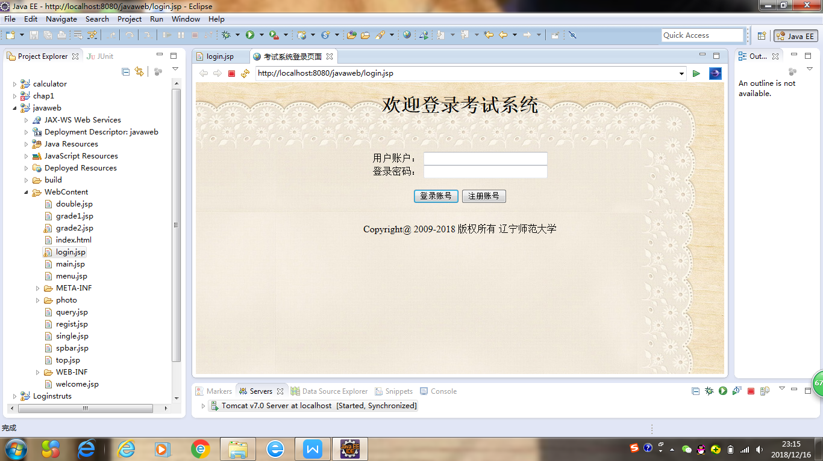

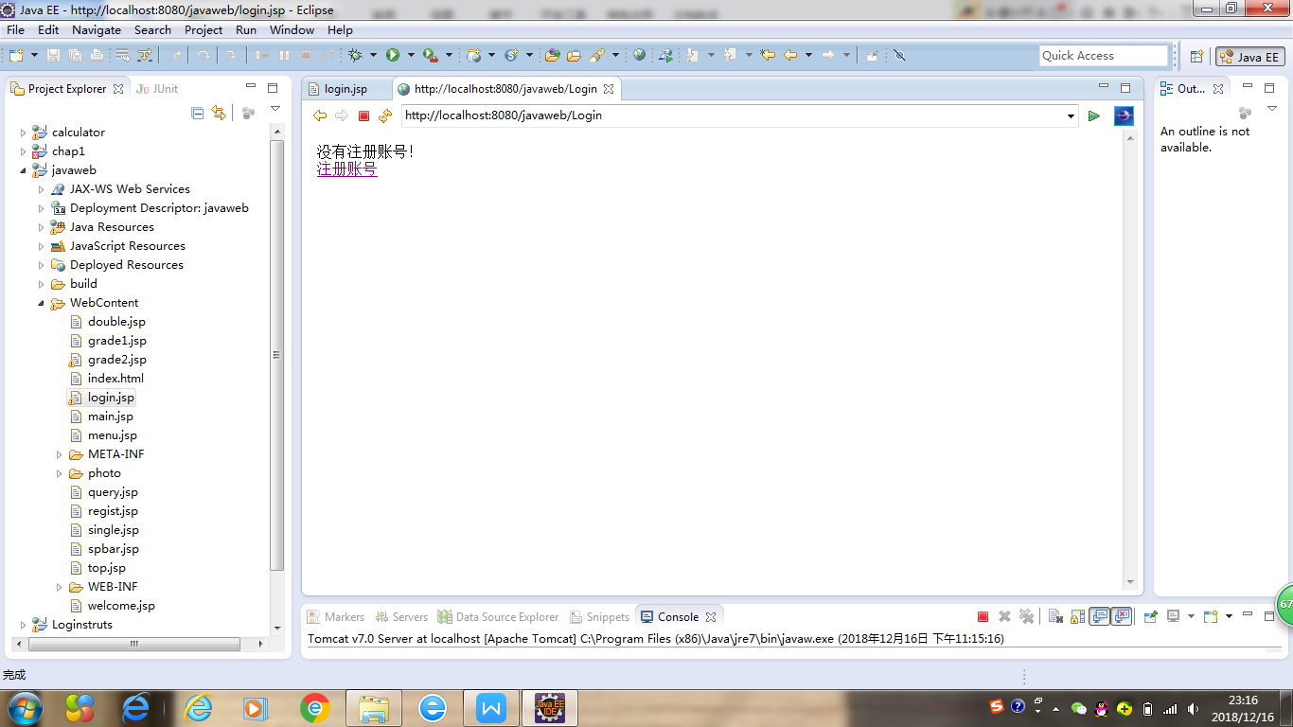

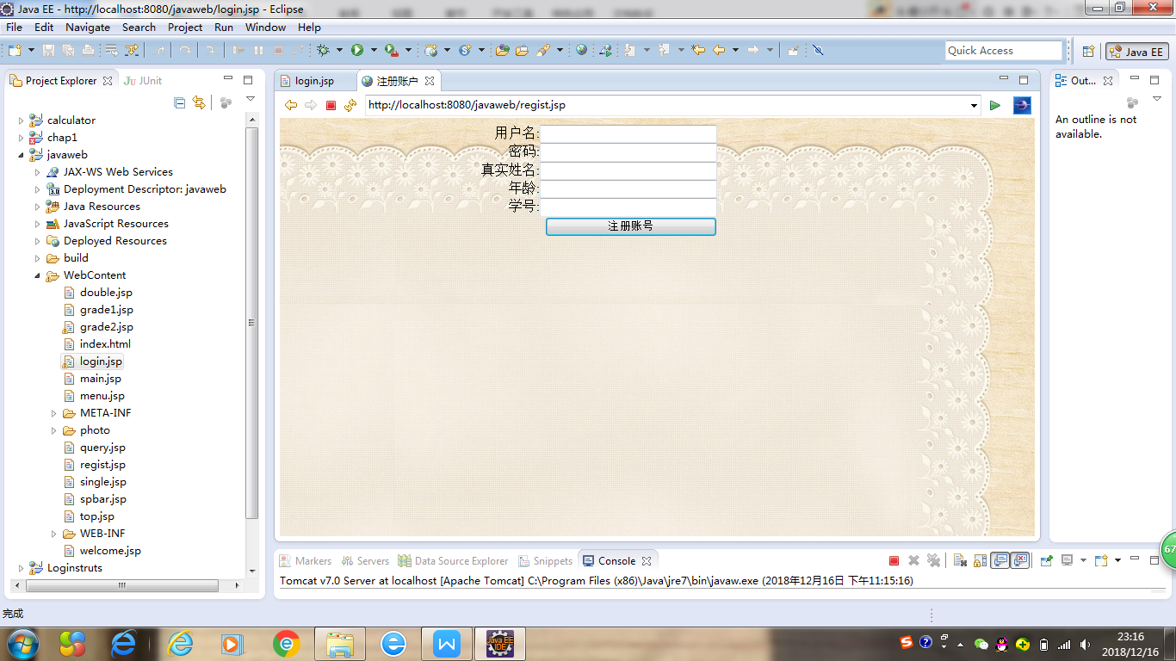

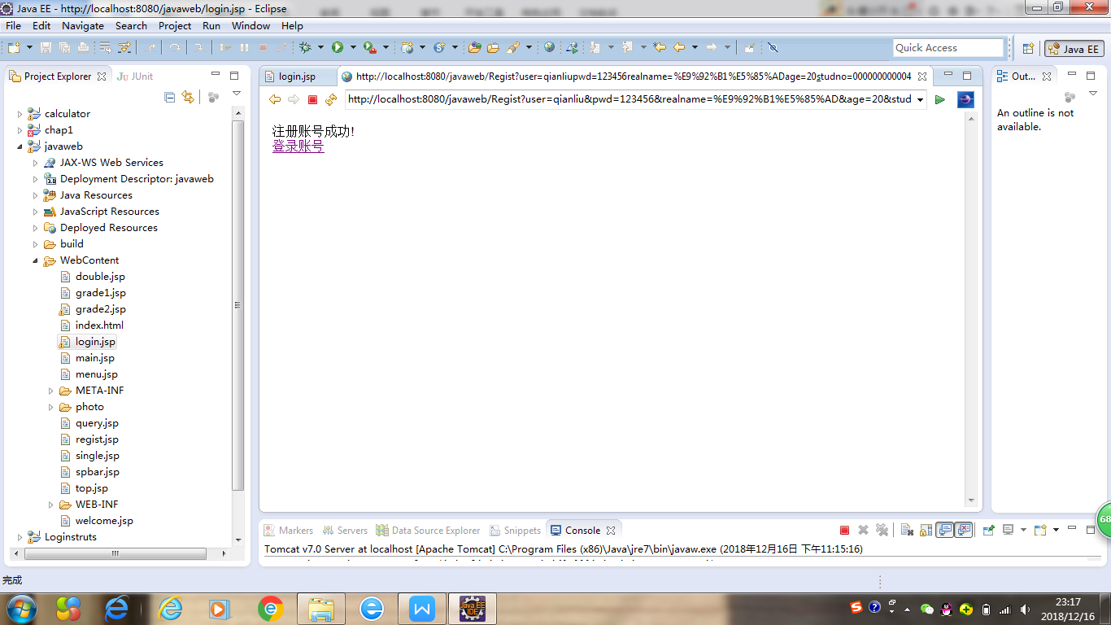

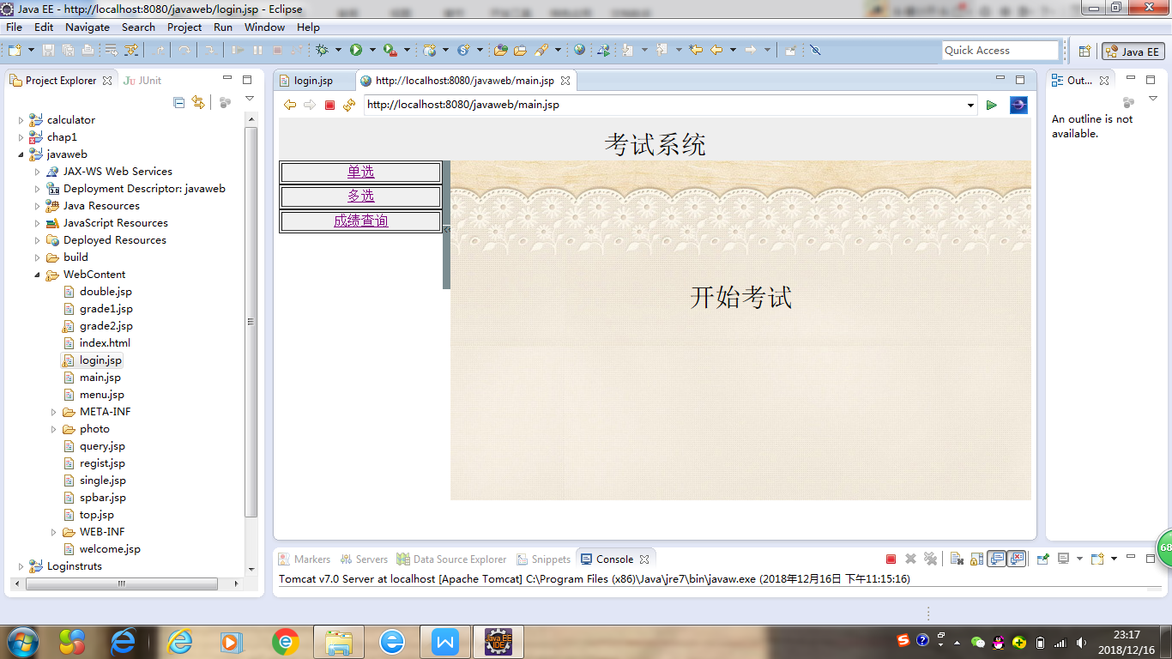

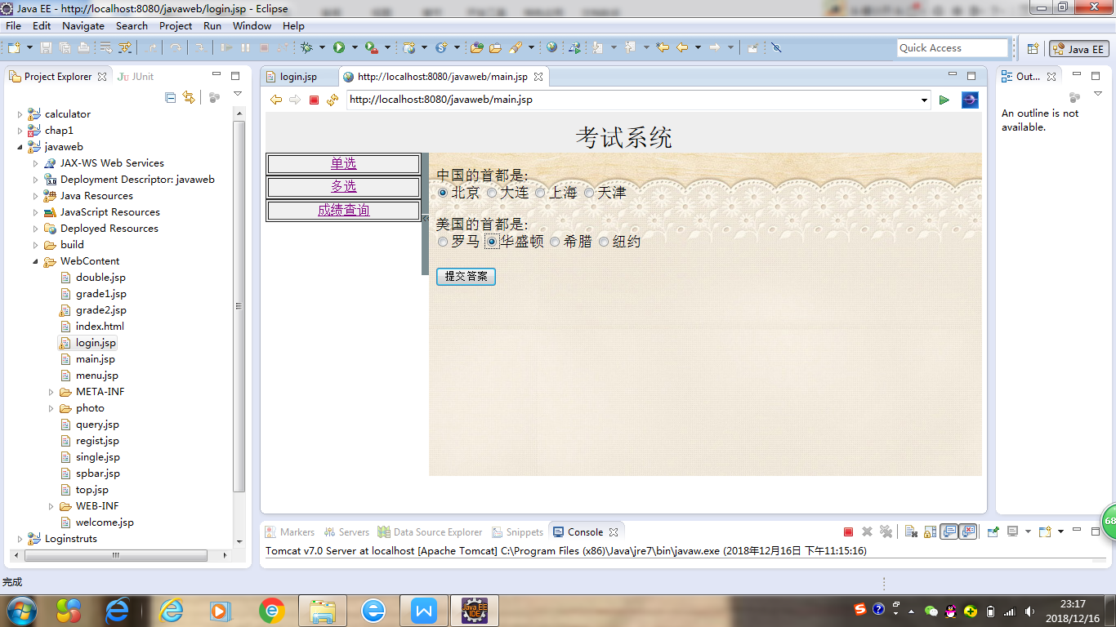

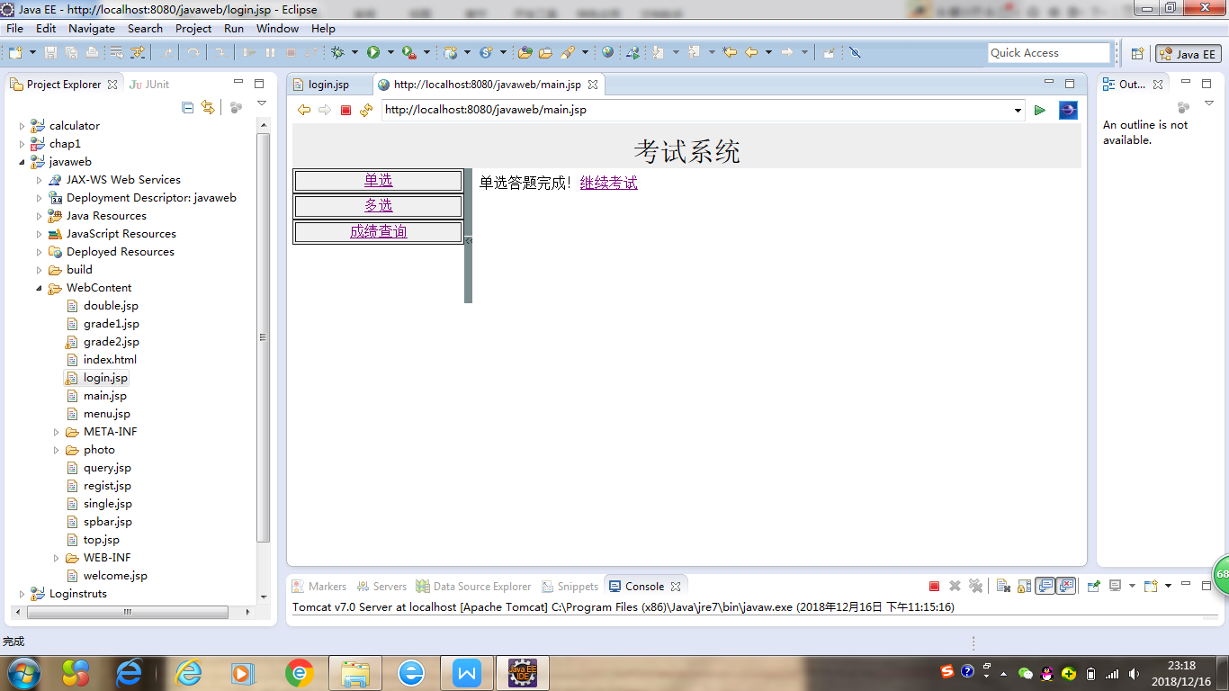

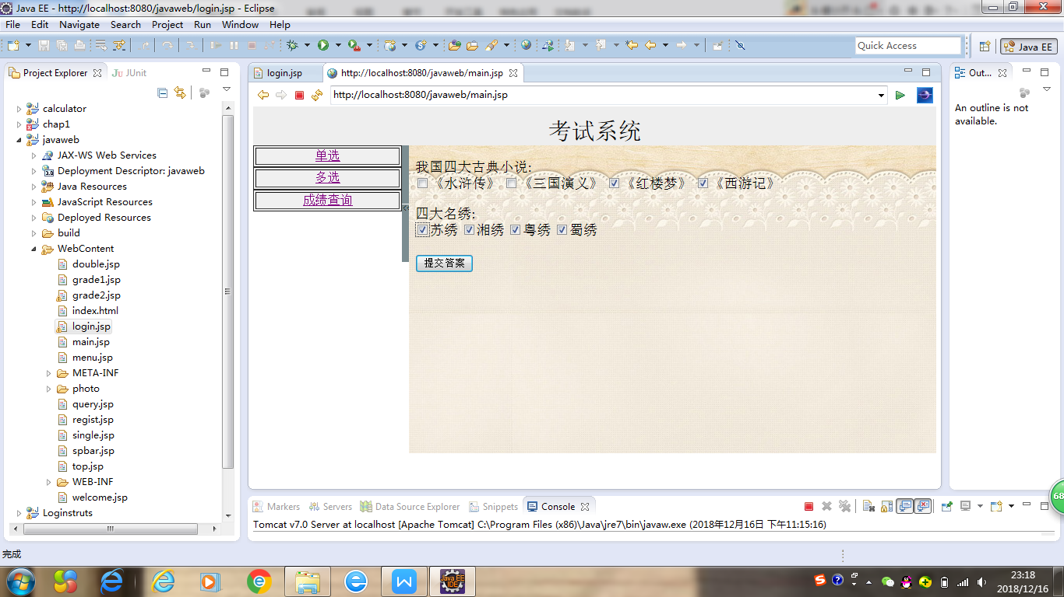

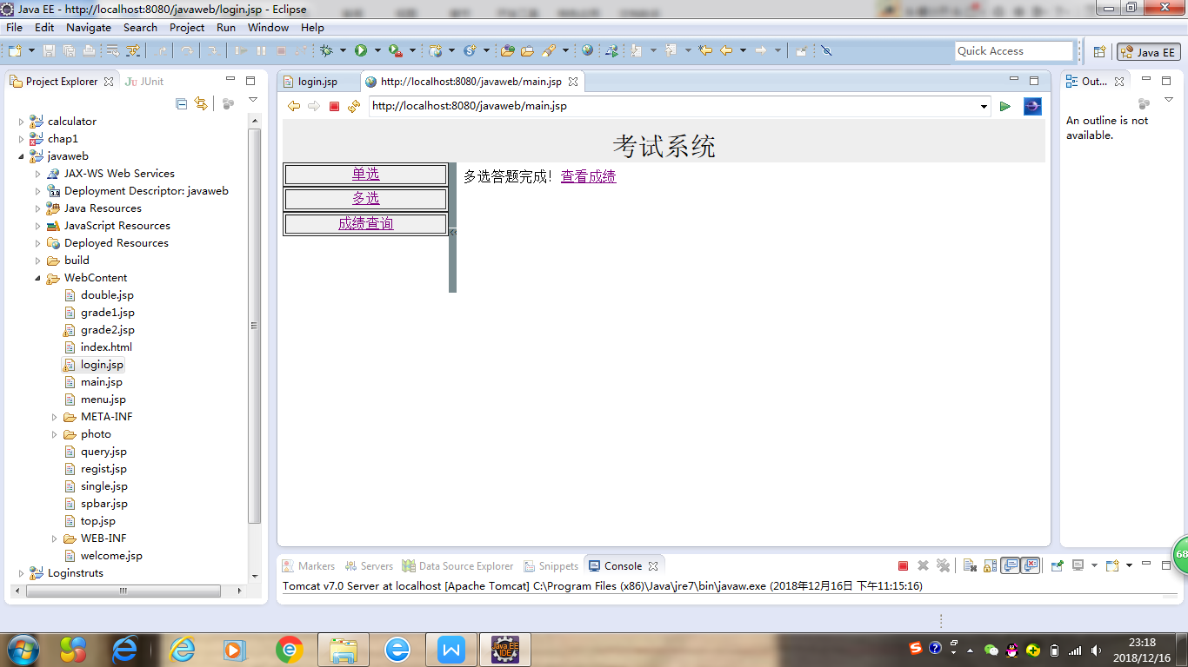

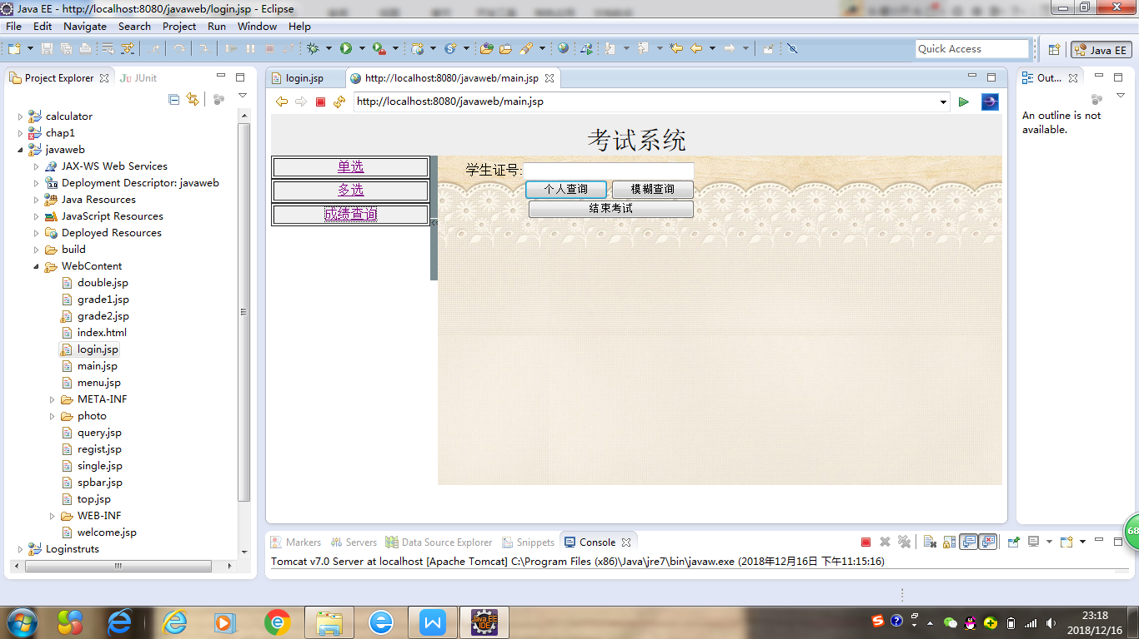

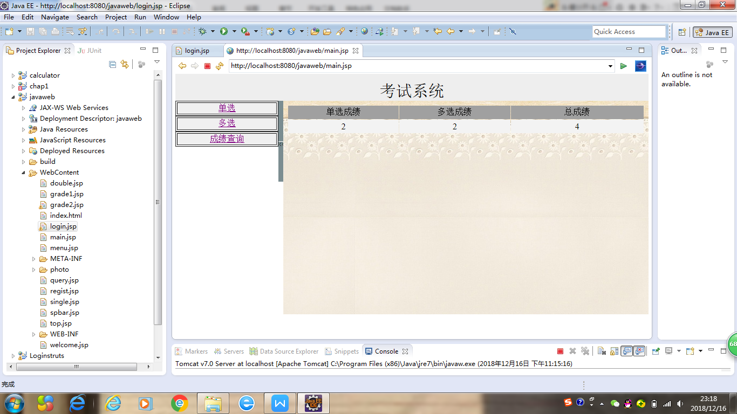

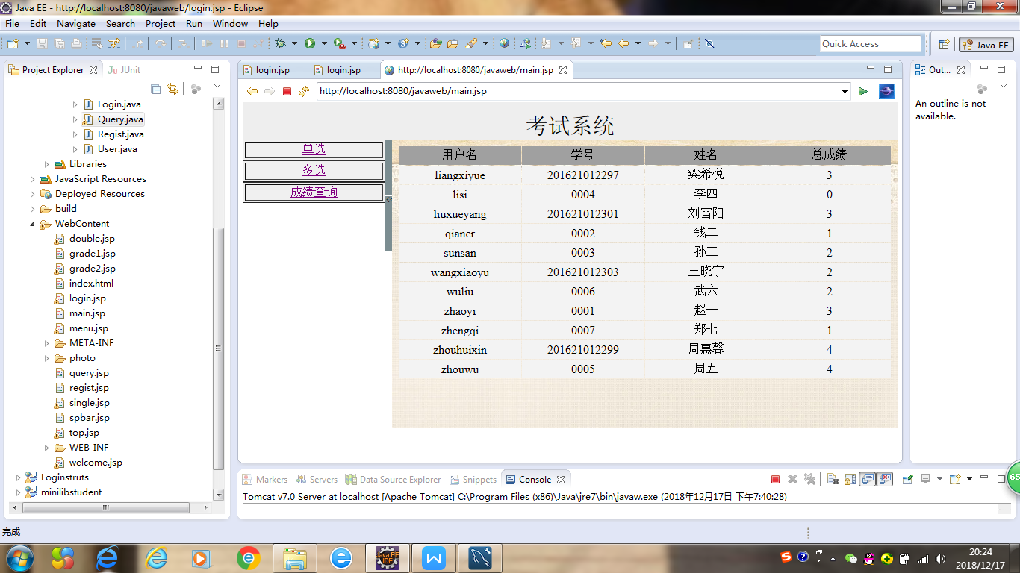

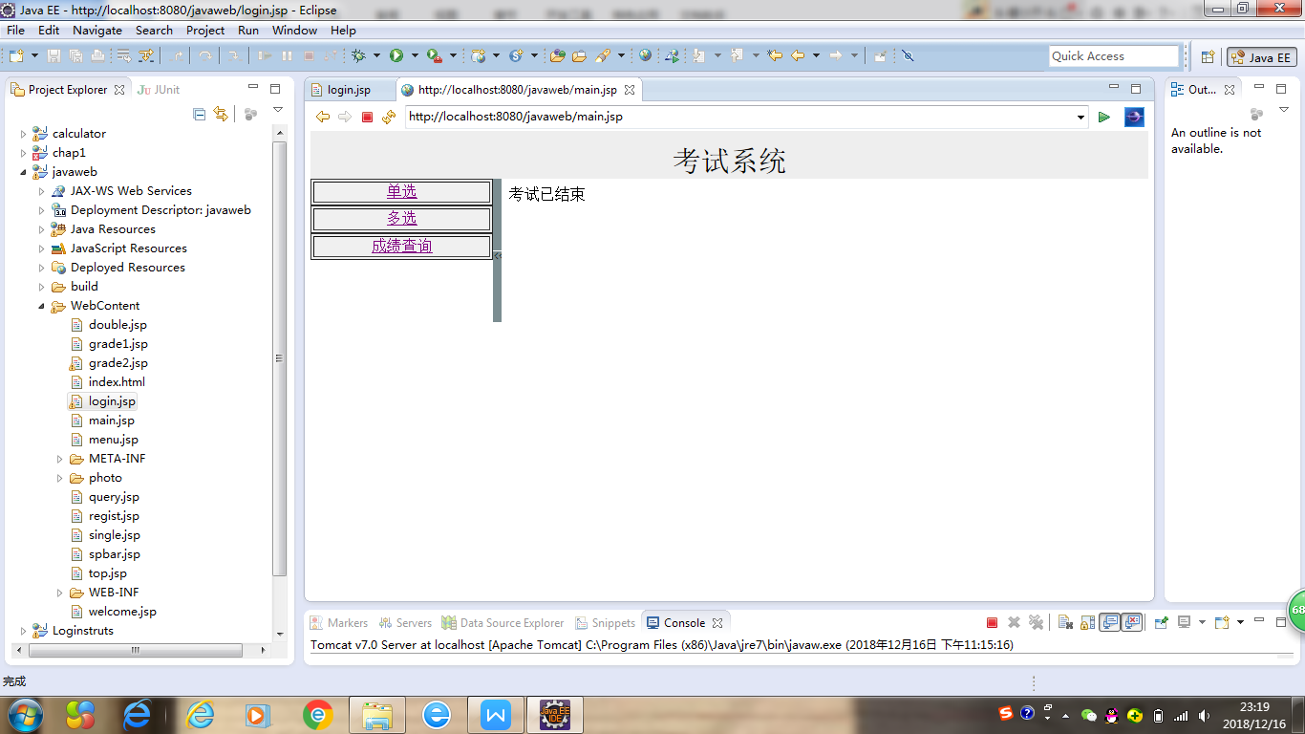

1. 实现结果分析

建立数据库的时候，主键要选择好，主键不可以重复。

用List传数据，要加import。

在jsp页面使用迭代器Iterator也要记得加import。

用session传数据的时候一定要检查名称前后是否一致。